Media Kit Lizzi Tremayne Author

Unpretentious, Eminently Readable
Contemporary and Historical Fiction.

Number one bestselling historical fiction author Deborah Challinor says of Lizzi’s historicals:

“Very descriptive, rich with research woven into the narrative, fairly informal and therefore eminently readable.”

Lizzi’s awarded historical and contemporary suspense, women’s, YA, and veterinary fiction has an equestrian flair, part and parcel of her other life as an equine veterinarian and carriage competitor.

The Long Trails historical fiction sagas follow a growing list of dashing heroes and heroines from the wilderness of 1860 Utah to Colonial New Zealand, Historical Scotland, and Tsarist Russia. Not necessarily in that order!

In the Once Upon a Vet School series, you’ll find the tale of a gutsy equestrian who dreamed of becoming a vet—her life on the way and beyond. Did YOU ever dream of becoming a vet?

Lizzi grew up riding wild in the Santa Cruz Mountain redwoods, became an equine veterinarian at UC Davis School of Veterinary Medicine, and practiced in the California Pony Express and Gold Country before emigrating to New Zealand. Her writing is awarded in fiction and veterinary nonfiction.
When she's not writing or reading, she's swinging a rapier or shooting a bow in medieval garb, riding, driving a carriage or playing on her hobby farm, singing, working as an equine veterinarian, or teaching high school science.

Hosts have said...

“Lizzi has a fascinating writing style as she wraps verifiable history into an adventure novel. She writes with accuracy and a rare talent for describing events and places. A fourth book is awaited with interest.

As a public speaker Lizzi rivals her talent as a writer. She has an engaging personality and an enthusiasm for describing her life and works.

I would strongly recommend her as a guest speaker to any organisation with an interest in history. You won’t be disappointed.”
—Murray Reid, Mangatangi Historical Group, New Zealand (full review at end)
“It was a real pleasure to have Lizzi speak at the Gore Library. Her research and knowledge about the subjects of her novels shows in the passion she has when presenting. We would love to have Lizzi back again in the future!”
—Penelope Perry, Senior Librarian, Gore District Libraries, New Zealand

“...a most enjoyable and informative talk as she talked us through her first three books and her passion for history. Her books are based around historical fact with fictional characters... and her talk drew a lot of questions from the floor.”
—Eric Muir, President, Franklin Historical Society, New Zealand
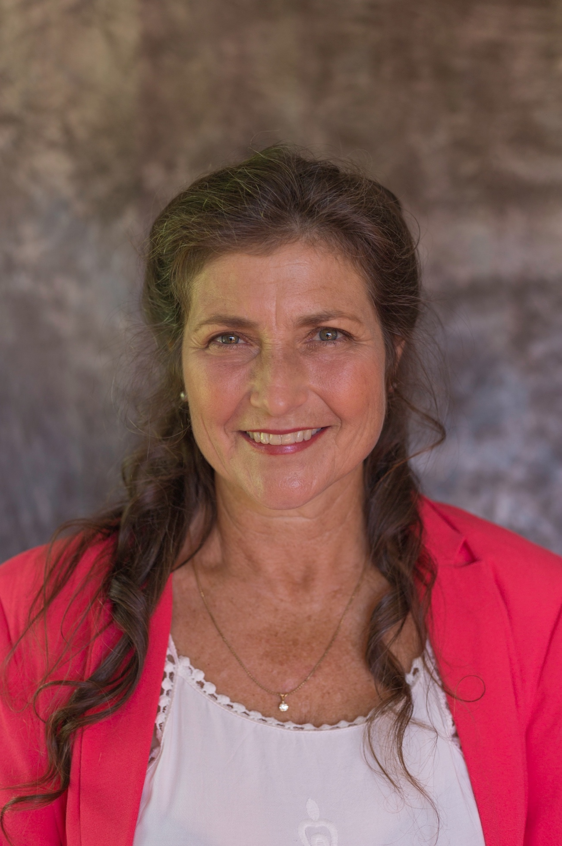

About the Author
Lizzi grew up riding wild in the Santa Cruz Mountain redwoods, became an equine veterinarian at UC Davis School of Veterinary Medicine and practiced in the Gold and Pony Express Country of California before emigrating to New Zealand. She is the proud mother of two boys in that sea of green. When she's not writing, she's swinging a rapier or shooting a bow in medieval garb, riding or driving a carriage, playing in the garden on her hobby farm, singing, cooking, being an equine veterinarian or high school science teacher. She is multiply published and awarded in special interest magazines and veterinary periodicals.
With her debut novel, A Long Trail Rolling, she was Finalist 2013 RWNZ Great Beginnings; Winner 2014 RWNZ Pacific Hearts Award for the unpublished full manuscript; Winner 2015 RWNZ Koru Award for Best First Novel and third in Koru Long Novel section; finalist in the 2015 Best Indie Book Award and Winner True West Magazine’s Best Western Romance 2016.
Lizzi’s two current series are: The Long Trails saga of Historical Suspense/ Women’s Fiction novels and the Once Upon a Vet School series of multiple semi-autobiographical, age-relative works of Contemporary Women’s through Children’s Fiction.
A speaker recommendation from the Mangatangi Historical Group follows the main text of this kit.
Her books are independently published by her own imprint, Blue Mist Publishing.

Lizzi’s website is at https://lizzitremayne.com
Her FB author page: https://www.facebook.com/lizzitremayneauthor/

By the Author:
The Long Trails Series
Books 1-3: The Long Trails Box Set: Historical Western Family Saga: Books 1-3
Can an orphan, with only her Mustang and a Cossack sword, survive alone on the frontier?

From the deserts of Utah, through the gold mines of California, to the turbulent wilderness of Colonial New Zealand, Aleksandra rides, loves, and fights—with only her Cossack skills to keep her alive.
Book One: A Long Trail Rolling
Hunted for her secrets. Hiding in plain sight. Can one woman blaze her own trail into untamed territory?
Winner of the Winner True West Magazine’s Best Western Romance 2016, Romance Writers of New Zealand: 2014 Pacific Hearts Award and 2015 Koru Award, Finalist Best Indie Book Award 2015.

UTAH TERRITORY, 1860. Aleksandra has spent her whole life training for the inevitable. So, when a brutal Cossack tracks down and kills her father, she instinctively collects her pa’s elixir and flees. But when she meets the mysterious Xavier at a nearby trading post, she wonders if she can win both his protection and his heart…

Disappointed when the man of her dreams leaves to join the Pony Express, Aleksandra dons a disguise to follow him into the dangerous frontier assignment. Hiding behind her martial arts skills and a male alias, she longs to tell the handsome Xavier the truth. But with the killer in pursuit, keeping up the ruse may be her only chance for survival…

Can Aleksandra save both her love and her family legacy from a relentless murderer?

Book Two: The Hills of Gold Unchanging
As the Civil War rages, secessionists menace California. The Confederates want the state and they'll stop at nothing to take it.
UTAH TERRITORY, 1860. On a wagon train headed West, Aleksandra makes an enemy of a gun-running Confederate when she fights her way out of his unwelcome embrace and Xavier's new friends realize he’s heard too much to be allowed to live. Embroiled in the Confederate’s fight to drag the new state from the Union and make it their own, can Aleks and Xavier survive? The secessionists mean business.

Book Three: A Sea of Green Unfolding
They set sail for the peace and calm of New Zealand, but they hadn’t counted on murderers, mutineers, and a land war in paradise.
SAN FRANCISCO BAY AND NEW ZEALAND, 1863. Tragedy strikes in Aleksandra and Xavier’s newly found paradise on their California Rancho but Von Tempsky’s invitation draws them to a new life in peaceful New Zealand. They disembark into a turbulent wilderness—with the opening shots of the New Zealand Wars just being fired—straight at them.

Novella: Somewhere Called Home
Highlands to Waterloo—can love prevail over fate?
SCOTTISH HIGHLANDS, 1813.
Robert is disowned for refusing to become clan tacksman after his father and heads for the city, alone, to build a life for himself and his beloved Sofia. Sofia’s waiting turns to despair when her mother buys safety during the clearance of their village—leaving Sofia at the mercy of the laird’s degenerate son. Rob emerges from the hell of Waterloo wanting only to see Sofia again... and his father. To be released soon.
The Tatiana Series
(with links to The Long Trails series)

Book One: Tatiana I
Stableman’s daughter Tatiana rises to glamorous heights by her equestrienne abilities—but the tsar’s glittering attention is not always gold.
MOSKVA, RUSSIA 1842. Tatiana and her husband Vladimir become pawns in the emperor’s pursuit of a coveted secret weapon. While Tatiana and their infant son are placed under house arrest, Vladimir must recover the weapon or lose his wife and young son. With the odds mounting against them, can they find each other again—half a world away? Coming soon!

The Once Upon a Vet School Series
Drama and humor abound as Lena pursues her childhood dream of becoming an equine vet—and beyond—in this unique series of six independent sequences:
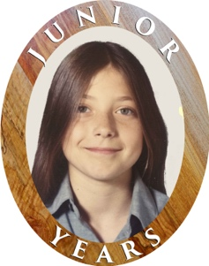
Cameos are placed on the covers of the books in each sequence for reader orientation.
~Junior Years~
After Lena hears she needs good grades to become a veterinarian, things start to get tricky. Even her pony doesn’t get out unscathed. (Middle Grade) USA 1972-1976
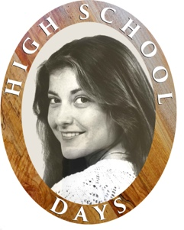
~High School Days ~
When your high school counsellor says vet school’s too hard for you and your HS sweetheart offers you a dream life of farming, writing, and babies, what do you do? Is vet school really the be-all, end-all? (Young Adult) USA 1976-1979
~College Nights
How can you have a life when you need an A in every class for four years to get into vet school... on top of 800 hours vet practice work? Something’s got to give. (Young Adult and up) USA 1980-1984
~Vet School 24/7~
Now they’re in, the pressure for grades is off and vet school social life is upon them... there’s only the tsunami of 200 years of veterinary knowledge to pack into their heads. Can Lena and her friends stay afloat? (Young Adult and up) USA 1984-1988

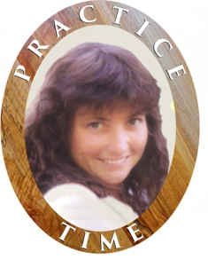
~Practice Time~
Finally graduated, prima ballerinas of the university, Lena and her vet school classmates disperse to far-flung practices... and real life. What could possibly go wrong? Late nights on-call, mud, blood, and finally, a light at the end of the tunnel... unfortunately, it’s only the penlight of a dictatorial vet technician in Lena’s eyes after she passed out on the floor. (Women’s Rural Fiction with Romantic Elements) USA & New Zealand 1988-2012

Stories of the Once Upon a Vet School Series
Currently Available Reads:

~Vet School 24/7~
Fifty Miles at a Breath
Horses bring them together and their future looks rosy—it’s the present they can’t handle.
When equine veterinary student Lena and veteran pilot Blake fall in love, vet school and the past intrude. Add in a long-distance relationship, and things get just plain hard. A grueling endurance race forces them to draw on their strengths and face their fears—together.
Lena Takes a Foal
She needs help... he needs to stay away...
Lena’s got a problem—one that might prevent her from graduating. When her horse flips over and lands on her, it has to be the dashing resident, Kit, who finds her. Luckily, she’s sworn off relationships after her last debacle and sea-green eyes and rugged good looks are the last things on her mind. Besides, to a veterinary school faculty, relationships between residents and students are like oil and water.
They just don’t mix.
~Practice Time~
Greener Pastures Calling
A new country, a great job, and a good Kiwi bloke. Life couldn't be better.
Until it gets worse.
Newly emigrated to New Zealand, Lena wants a ‘good Kiwi bloke’, but they’re elusive as their nocturnal namesake. Nigel’s avoiding females, unless they’re cows, horses, or his mother after his first marriage. Sparks fly when they meet—but not the first time, over the dirty instruments in a filthy cowshed. They seem to be made for each other, until Nigel remembers where he first saw her. And then the questions start.

SHORT VERSION OF OAVS SERIES:
The Once Upon a Vet School Overall Series
Drama and humor abound as Lena pursues her childhood dream of becoming an equine vet—and beyond—in this unique series of six independent story sequences:
~Junior Years~
After Lena hears she needs good grades to become a veterinarian, things start to get tricky. Even her pony doesn’t get out unscathed. (Middle Grade) USA 1972-1976
~High School Days ~
When your high school counsellor says vet school’s too hard for you and your HS sweetheart offers you a dream life of farming, writing, and babies, what do you do? Is vet school really the be-all, end-all? (Young Adult) USA 1976-1979
~College Nights
How can you have a life when you need an A in every class for four years to get into vet school... on top of 800 hours vet practice work? Something’s got to give. (Young Adult and up) USA 1980-1984
~Vet School 24/7~
Now they’re in, the pressure for grades is off and vet school social life is upon them... there’s only the tsunami of 200 years of veterinary knowledge to pack into their heads. Can Lena and her friends stay afloat? (Young Adult and up) USA 1984-1988
~Practice Time~
Finally graduated, prima ballerinas of the university, Lena and her vet school classmates disperse to far-flung practices... and real life. What could possibly go wrong? Late nights on-call, mud, blood, and finally, a light at the end of the tunnel... unfortunately, it’s only the penlight of a dictatorial vet technician in Lena’s eyes after she passed out on the floor. (Women’s Rural Fiction with Romantic Elements) USA & New Zealand 1988-2012

Currently Available The Stories of the Once Upon a Vet School Series
~Vet School 24/7~
Fifty Miles at a Breath (III)
Horses bring them together and their future looks rosy—it’s the present they can’t handle.
Lena Takes a Foal (IV)
She needs help... he needs to stay away...
~Practice Time~
Greener Pastures Calling (II)
A new country, a great job, and a good Kiwi bloke. Life couldn't be better.
Until it gets worse.

Understanding Modern Vet Med for Owners
The new series of veterinary books for horse owners to let you use what vets know to keep your horses healthier and happier. First volume due out soon!

With Bluestocking Belles
Boxed sets of historical love stories from a host of bestselling authors.
Follow Your Star Home

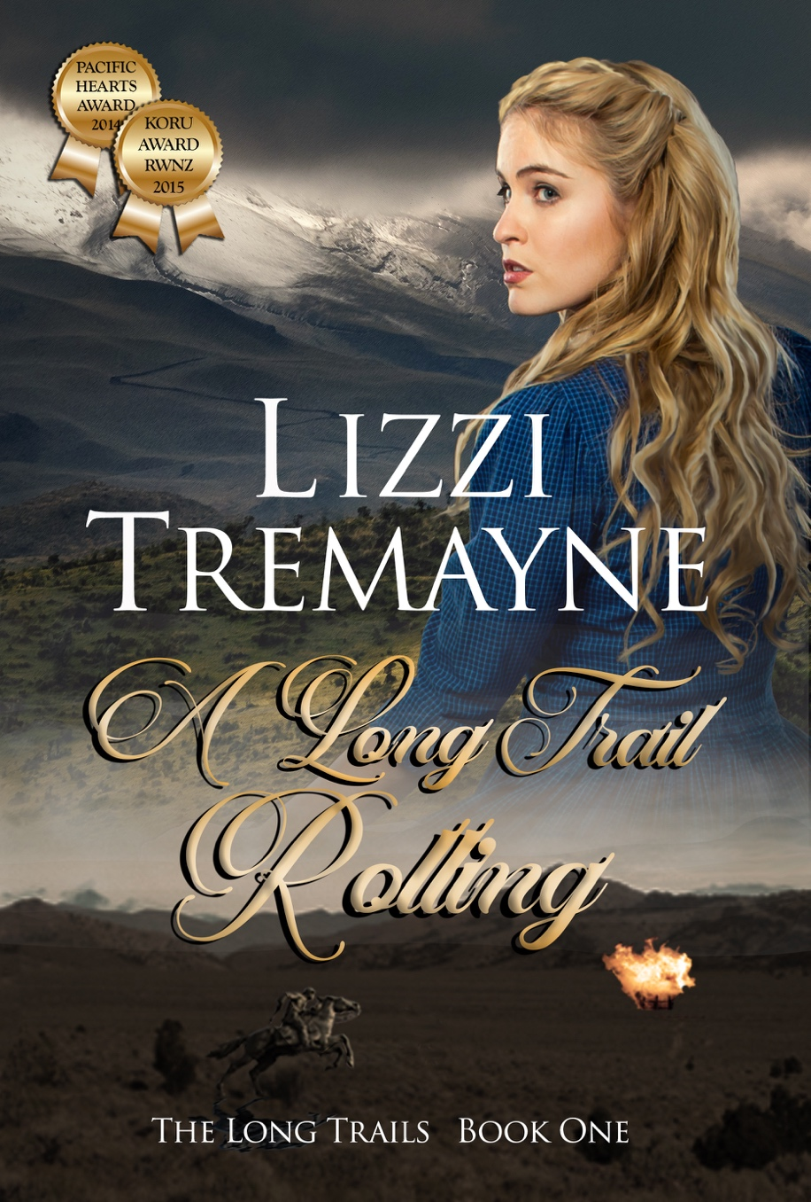
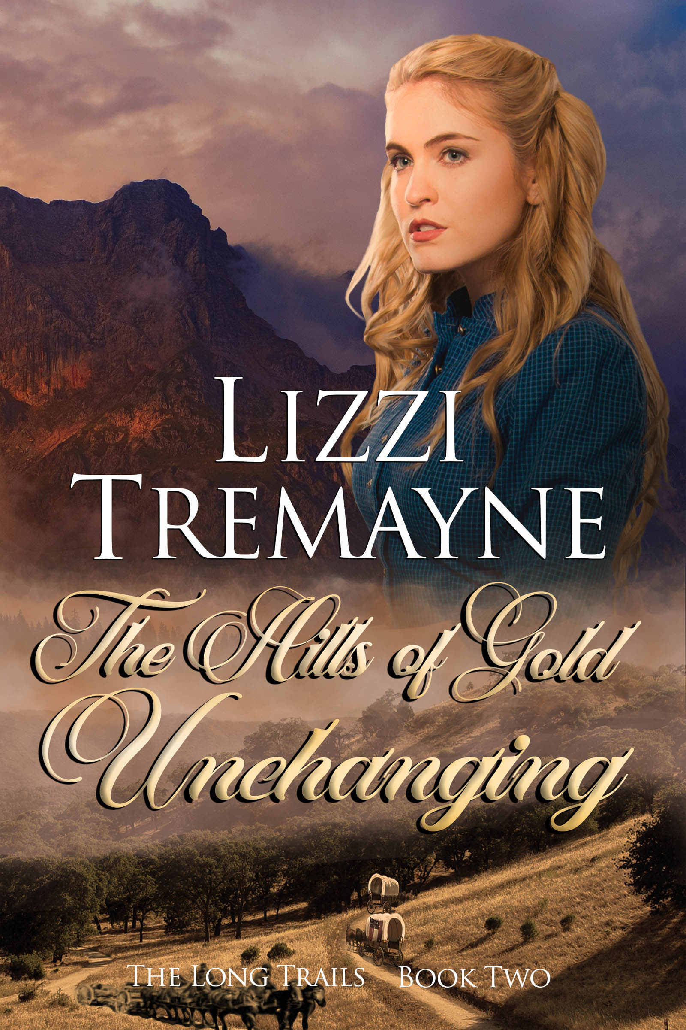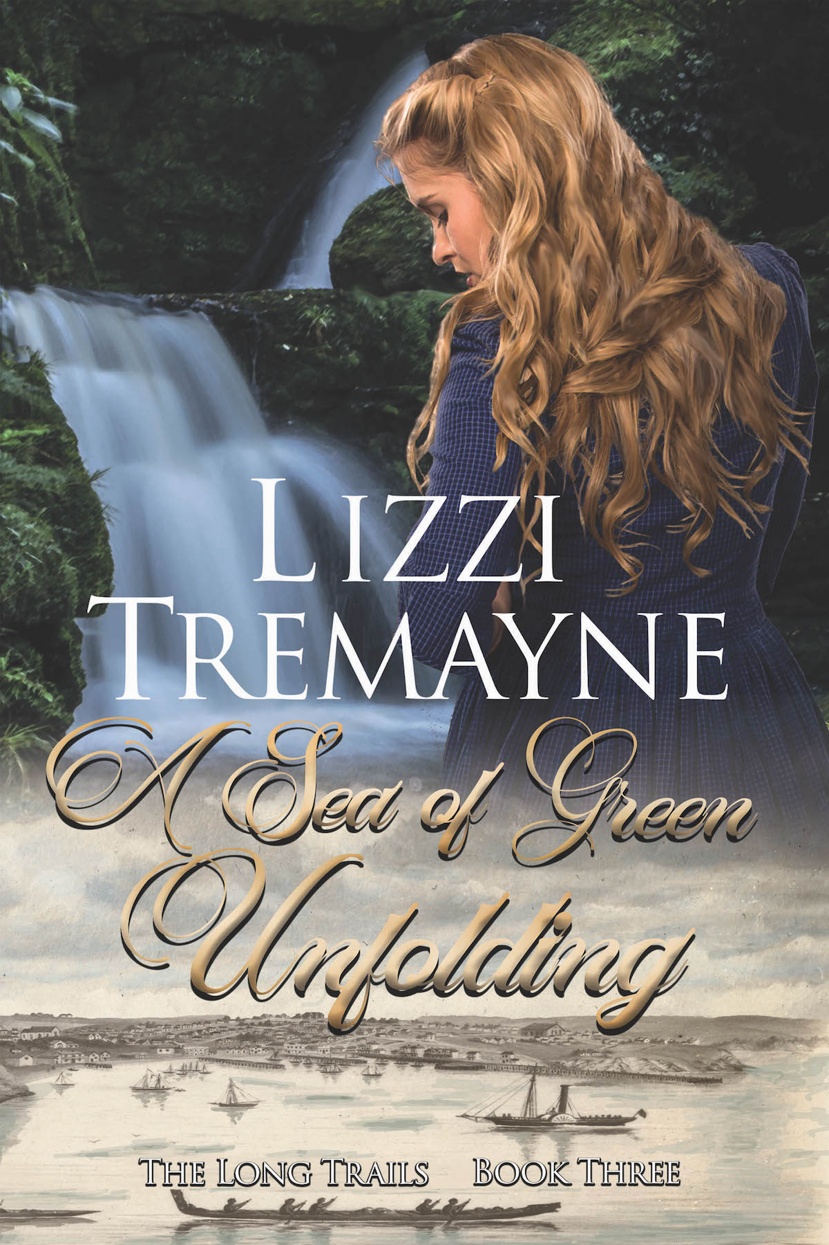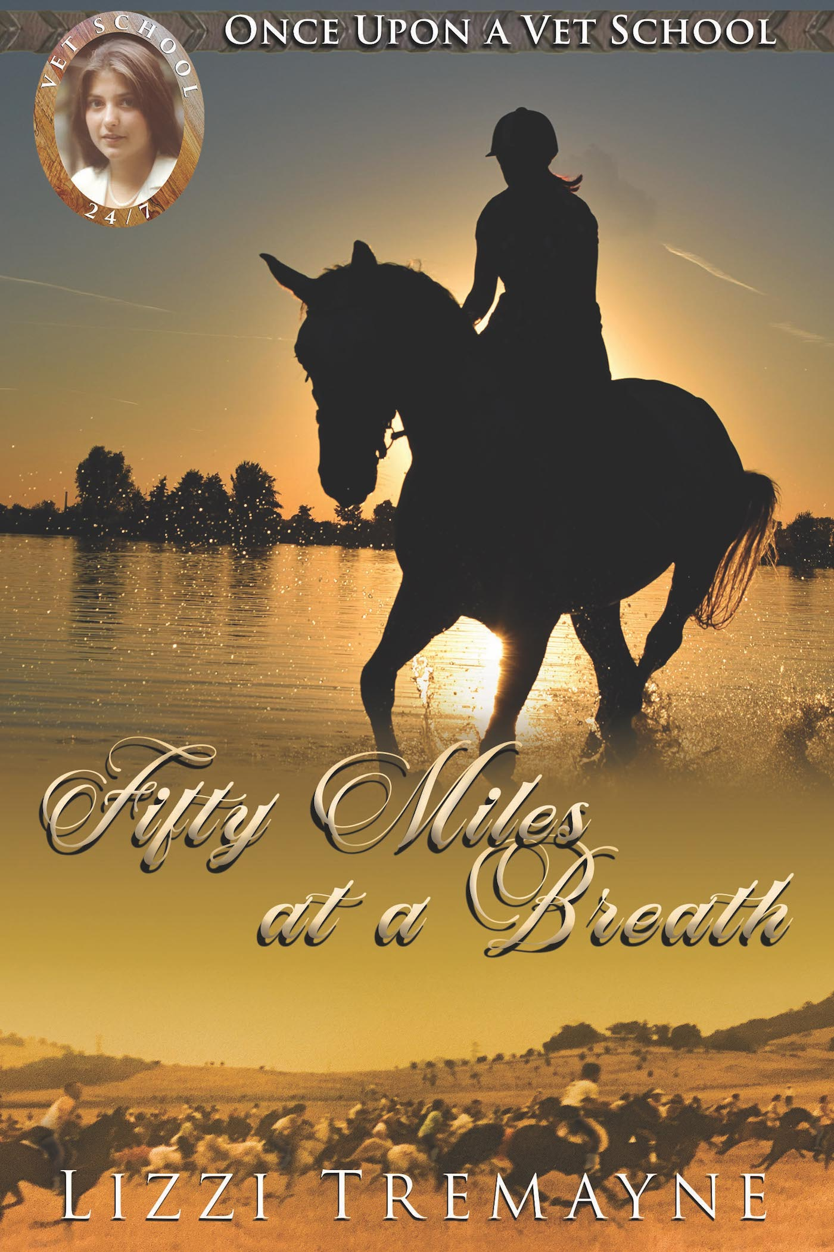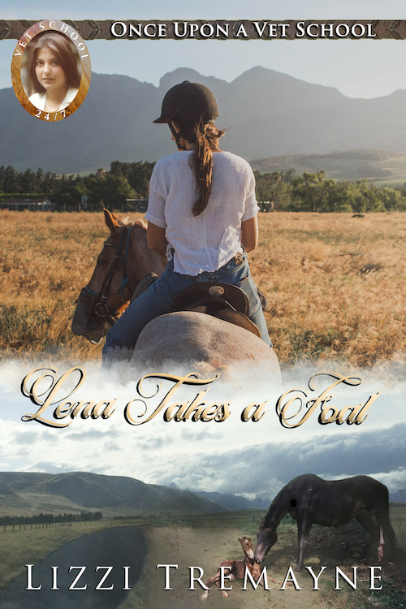
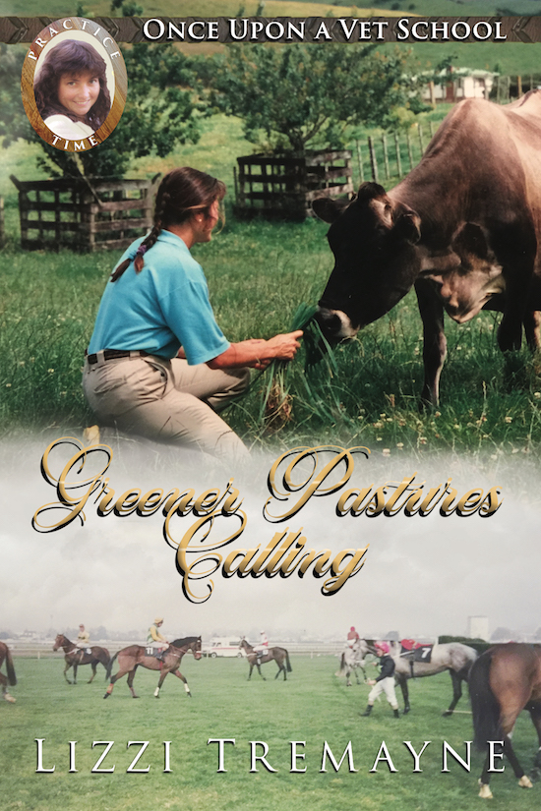

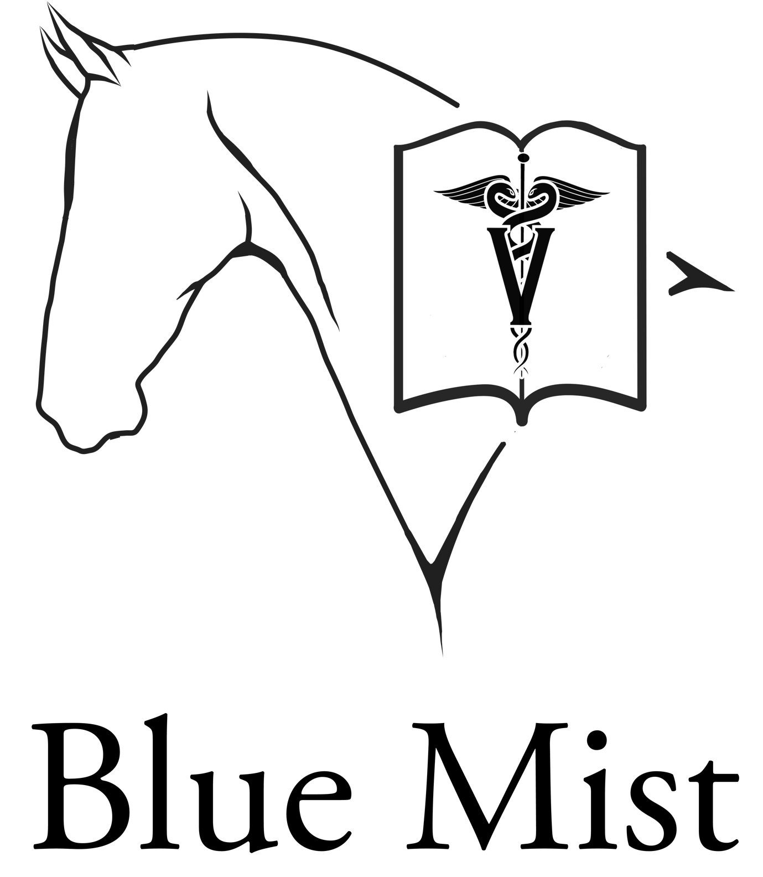

Logos are PNGs, use as you wish. The script one is lovely, but illegible when small.

Thanks for your interest and hope to hear from you soon!

If you need larger files of any images, please let me know.
Thanks so much for your consideration!

Regards,
Lizzi
Speaker recommendation from the Mangatangi Historical Group

Lizzi Tremayne was guest speaker at our monthly meeting in July 2017.

We chose Lizzi as one of our members had recently read her series of books, the third of which was Sea of Green Unfolding.

That novel followed the journey of Aleksandra and Xavier in New Zealand in 1863 at the beginning of the Waikato Wars. They travelled from California to the East Coast of the North Island where they were separated following a shipwreck. Most of the tale chronicles the solo trek of Aleksandra from Coromandel to Auckland via the Hauraki swamps and North Waikato. Near Miranda (Pūkorokoro) she came across the newly built defensive Redoubt and was then escorted by soldiers through the district to Auckland.

The Mangatangi Historical Group has its base in the area through which her trek was made. As such we were very interested in how Lizzi recorded the history of our patch, 150 years later.

Lizzi has a fascinating writing style as she wraps verifiable history into an adventure novel.
She writes with accuracy and a rare talent for describing events and places. A fourth book is awaited with interest.

As a public speaker Lizzi rivals her talent as a writer. She has an engaging personality and an enthusiasm for describing her life and works.

I would strongly recommend her as a guest speaker to any organisation with an interest in history. You won’t be disappointed.

Murray Reid
Mangatangi Historical Group
Leamington
Cambridge, New Zealand

